Code Review

Acceptance criteria
- Done - Only display products that are published
- Done - Adding to my cart removes item from product list
- Done - Removing item from cart, adds item back into product list
- Done - Responsive view that works across mobile and desktop devices
- Done - WCAG 2.1 AA compliant
- Done - Semantic markup
Code Review
The good:
- It implements some of the requirements
- It is split into components

The bad:
- Error in the console, not using unique keys
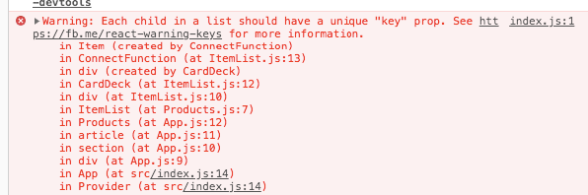
- Inline styling
- Products not aligned in iPad view
- No unit tests
- Cannot change the quantity in the cart

